**WIREFRAME DESIGN**

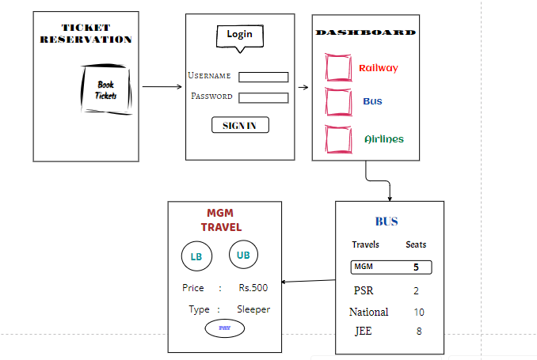

**USER INTERFACE**

<https://www.figma.com/design/1UPJzpOoJ6hdGEPmeX1cwh/ticket-reservation-ui?node-id=0-1&t=wL7UN4JljxZOJQnA-1>

